APPIUM SETUP IN WINDOWS

1.Install Java devlopment kit

Visit the [Java downloads page on Oracle’s](http://www.oracle.com/technetwork/java/javase/downloads/index.html) website to find the **JDK environment** download. Scroll down until you find **Java SE Latest Version** and download **JDK**.

2 Set UP Java Environment Variable in Windows

Environmental variables are used by the operating system to save settings (default values, locations of resources) to be used by Windows or by processes launched by users.  
There are two types of environmental variables:

* User Variables : Specific to a particular Windows user account
* System variables : For all the user of the machine

follow link to SET IT UP

**https://docs.oracle.com/cd/E19182-01/820-7851/inst_cli_jdk_javahome_t/**

3. Install Android SDK / ADB on Windows

Android is an *Operating System for mobile devices* developed by Google, which is built upon Linux kernel. Android competes with Apple’s iOS (for iPhone/iPad), RIM’s Blackberry, Microsoft’s Windows Phone, Symbian OS, and many other proprietary mobile OSes. The Android Software Developer Kit, simply named as Android SDK, or ADB is what all the advance users of Android should have installed on their Windows running computers.

STEPS

1.download and install Android studio or Android SDK

https://developer.android.com/studio/index.html

2. Go to the folder, where the Android installation was done. I did it at the default location and on my system it is at *C:\Users\User1\AppData\Local\Android/SDK*

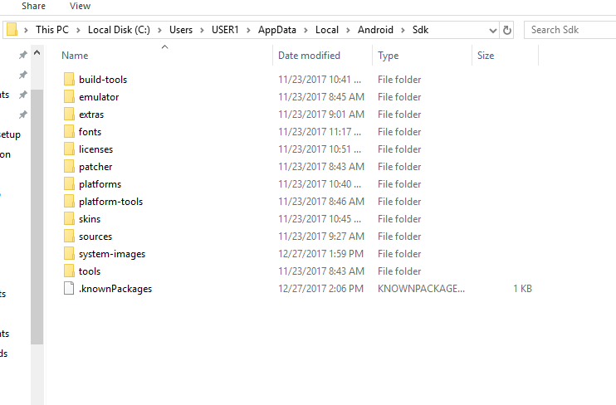

*3.*SETUP ANDROID ENV VARIABLES

https://developer.android.com/studio/command-line/variables.html

4.Download and Install Node.js

## What is Node.Js?

Appium is an HTTP server written in node.js which creates and handles multiple WebDriver sessions for different platforms like iOS and Android. Automating hybrid and native mobile applications for Android and iOS is a key function handled by Appium, a node.js server. One of the core tenets of Appium is that test codes can be written in any framework or language like Ruby on Rails, C# and Java without having to modify the apps for automation purposes. The interaction between node.js server and Selenium client libraries is what ultimately works together with the mobile application.

Visit the [***Node.JS***](https://nodejs.org/en/download/) website to download Node.JS. Scroll down little bit  to find the correct installer for your OS version.

5. Visit the [***Appium Download***](http://appium.io/downloads.html) page to install the Appium Desktop client. Click on ***Appium.exe for Windows*** to download the ‘***.exe***‘ file for Appium.

6.For Appium Console type Command npm install -g appium on console window